**Christopher King**

**2018141521058**

**Applied Fluid Mechanics**

**Class Section 01**

**03/30/2021**

# **Problem 8.68**

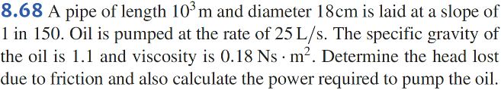

**Solution:**

Therefore, the head lost due to friction is

# **Problem 8.75**

**Solution:**

Therefore,

# **Problem 8.108**

**Solution:**

Therefore,